PROJECT PROPOSAL FOR INNOVATE AND LEARN GRANT
Voice Uganda

- PROJECT OVERVIEW
A.1. Project Title:

A.2. Name of the (Lead) Applicant Organisation:

Address:

Telephone No.: | Email Address:
Contact Person and Designation: | Alternate Contact Person:
Registration Details: | Date Registered:
A.2 (b). Name of Co-applicant (s) – List names of organisations if application is by a consortium

A.3. Project Duration:

A.4. Proposed Budget:

A.5. Project Geographical Coverage/Area:

A.6. Target Group/s:
Select all that apply.
( ) Persons with disability
( ) Age-discriminated groups (youth and the elderly)
( ) LGBT community
( ) Indigenous peoples
( ) Women facing exploitation, abuse and/or violence
A.7. Thematic Area:
Select all that apply.
( ) Increasing access to productive resources (i.e. finance, land, and water) and employment
( ) Increasing access to social services, health and education in particular
( ) Strengthened space for political participation
A.8. Project Summary:
Brief but specific statement of the proposed project objectives, methods and impact.
Be succinct and to the point!
(max. 500 words)

- PROJECT NARRATIVE
Please see the learning cycle below to help you understand better the intention of Innovate and Learn Grant and how to fill the forms/ questions
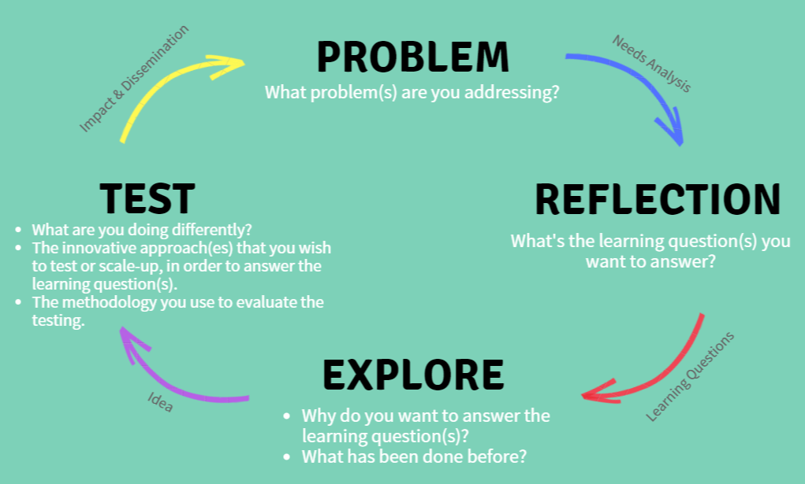

B.1. Problem: Needs Analysis
Tell us the issues you face or faced by the target group(s) you will be working with. Focus on the specific needs that you wish to address with this project, especially in regards to access to resources, services and participation in decision making. (max. 300 words)

B.2. Learning Questions
What questions will this proposed project try to answer? These questions are at the core of the innovation you want to test or scale-up. They will need to be answered at the end of the grant period.

“The usefulness of the knowledge we acquire and the effectiveness of the actions we take depend on the quality of the questions we ask.” Eric Vogt

…..

B.2. Explore
Explain why your organisation wishes to answer these learning questions, include the following considerations: (a) how the learning fits within your organisation’s strategic plan; (b) what the grant funds will allow you to do differently or more effectively; (c) the impact this project would have on your organisation; and (d) any other organisations or individuals who are collaborators in this endeavour. (max. 500 words)

B.4. Test: The Innovation
Tell us about the innovative approach that you wish to test and/or review. Provide a description of your pilot, including the following: (a) why was the new approach tried? (b) the degree to which it was research and/or evidence-based; (c) the specific goals, outcomes and measures of success; (d) a fuller description of the people the project supported (i.e. race/ethnicity, age, gender, socioeconomic status and geographic location) in empowering and in strengthening their lobby and advocacy capacities; and (d) how it supported the lessening of marginalization of the target groups and addresses Voice themes. (max. 500 words)

Methodology used to evaluate the innovation
Include specifics of the study design, study area (geographic), required preparation for fieldwork (if any), sampling criteria, methods of data collection and data processing and collection. Also, outline any testing or action research you wish to undertake. Please also complete Table A below. (max. 500 words)

B.4. Impact and Dissemination
How will the target group(s) and others working with the target group gain knowledge through your learning? What do you think others can do with the knowledge gained? (Describe in the detail the plan to disseminate the findings how it is expected the target audience will use findings).
(max. 300 words)

B.6. Monitoring/Reporting
This section is for you to describe how you will keep track of your project. How will you know that the activities are successful? (max. 300 words)

B.7. Risk Assessment
Describe the risks that could limit the success of the project and your plans to mitigate this risk.
 | Risk | Likelihood  (L-low, M-medium,  H-high) | Mitigation Strategy
1.
2.
3.
…

B.8. Additional Comment
Use this section to make any additional comment about your proposal. Please also make comment on any help you might need to implement this project.

- ORGANISATIONAL BACKGROUND
C.1. Overview of the Organisation
Describe the goal of your organisation, your main programs or activities, your organisation’s most important accomplishments/outcomes, and what is unique about your organisation. (max. 500 words)

C.2. Geographical Reach and Professional Character
Tell us about your organisation’s identity. (max. 200 words)

C.3. Stakeholder Participation
Tell us how you develop your activities. How do you interact with the target-group and plan your activities with them? (max. 200 words)

C.4. Partners and Linkages
Please describe your previous and current partners, networks and other linkages. What kind of engagement do you have with them? (max. 300 words)

C.5. Donors
Please tell us your previous (in the last 2 years) and current donors and contact details of at least 2 of them. (max. 200 words)

C.6. Human Resources
What is the size of your organisation and the total number of full-time and part-time employees including a breakdown by gender?

C.7. Governance
Provide your organisation’s Board of Directors or similar governing body, the names, and contact information for the Board Chair or President and other members. In addition, provide information on how often the board meets in the last two years.
Full Name | Position | Contact Detail

C.8. Accountability and Transparency
Tell us how your organization demonstrates accountability and transparency in your commitments to the donors, communities, and your target groups. (max. 200 words)

Table A: Work Plan with Summary Activities, Expected Results, timeframe, and expected budget
Project Objective/s:

Description of Activities | Timeframe (weeks or months) |  |  |  |  |  |  |  |  |  |  |  | Expected budget in Ksh.
 | 1 | 2 | 3 | 4 | 5 | 6 | 7 | 8 | 9 | 10 | 11 | 12
1.
1.1
1.2
2.
3.
4.
5.
6.
7.
8.
9.
...
Management and Administration
Other direct cost
Total budget for expected proposal
Note: You may develop your own Excel Spreadsheet with detailed itemized costs in completing this budget proposal

