PROJECT PROPOSAL – Innovate & Learn Grant
PROJECT OVERVIEW

1. Title of the project:
Title of the project.
2. Name of the applicant organisation:
Name of the applicant organization.
Registration Details: Please provide details of how your organization is registered..
Date of Registration: Click or tap to enter a date.
3. Contact information of the applicant organization.
Address: Physical Address Only (No P.O. Box).
Full Name and Position of Main Contact Person:
Full Name, Position
Phone number: (Please include country code).. Email: (Please include email address).
Full Name and Position of Alternate Contact Person:
Full Name, Position
Phone number: (Please include country code).. Email: (Please include email address).
3. Name of Co-applicant(s) (List names of organisations if application is by a consortium):
Click or tap here to enter text.
4. Project Period (How many months?):From 12 up to 24 months.
5. Proposed Budget (How much will the proposed project cost?):
Total Amount Requested in Euros.
6. Proposed start date and end date of this project:
From: Click or tap to enter a date. Until: Click or tap to enter a date.
7. Voice target groups (Select all that apply):
☐ LGBTI+ ☐ Indigenous Peoples and/or Ethnic Minorities
☐ Age Discriminated Groups (Youth or Elderly) ☐ People with Disabilities
☐ Women facing exploitation, abuse and/or violence
8. Geographical scope (Select all that apply):
☐ East Africa / ☐ South East Asia / ☐ West Africa
Please list the specific countries: Click or tap here to enter text.
9. Thematic Area (Select all that apply):
☐ Increasing access to productive resources (i.e. finance, land, and water) and employment
☐ Increasing access to social services (i.e. health and education)
☐ Increasing space(s) for political participation
10. Short project summary:
Brief but specific statement of the proposed project objectives, methods and impact. Keep it clear and simple (Max. 500 words).
Click or tap here to enter text.

PROJECT DESCRIPTION

Please see the learning cycle below to help you understand better the intention of innovate and learn grant and how to fill the forms/ questions:

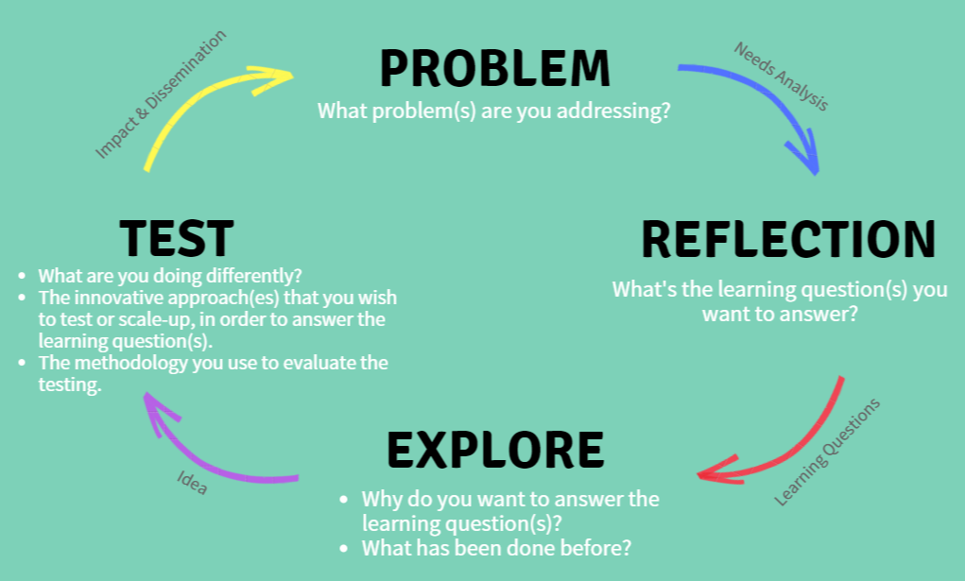

The Problem or Needs Analysis: What is the issue/problem you want to address?
Tell us the issues faced by you and your members particularly as they relate to access to resources, social services and/or participation in decision making either at household or political level (Max. 300 words).

Click or tap here to enter text.

Learning Questions: What questions will this proposed project try to answer?
These questions are at the core of the innovation you want to test or scale-up. They will need to be answered at the end of the grant period.

“The usefulness of the knowledge we acquire and the effectiveness of the actions we take depend on the quality of the questions we ask.” Eric Vogt

1. Measurable result.
2. Measurable result.
3. Measurable result.
4. Measurable result.
5. Measurable result.
6. Measurable result.

Explore: Explain why your organisation wishes to answer these learning questions.
include the following considerations: (a) how the learning fits within your organisation’s strategic plan; (b) what the grant funds will allow you to do differently or more effectively; (c) the impact this project would have on your organisation; and (d) any other organisations or individuals who are collaborators in this endeavour.

Click or tap here to enter text.

Test your innovation: Tell us about the innovative approach that you wish to test and/or review.
Provide a description of your pilot, including the following: (a) why was the new approach tried? (b) the degree to which it was research and/or evidence-based; (c) the specific goals, outcomes and measures of success; (d) a fuller description of the people the project supported (i.e. race/ethnicity, age, gender, socioeconomic status and geographic location) in empowering and in strengthening their lobby and advocacy capacities; and (d) how it supported the lessening of marginalization of the target groups and addresses Voice themes (Max. 500 words)

Click or tap here to enter text.

Methodology used to evaluate the innovation: How will you know that your approach or activities are successful?.
Include specifics of the study design, study area (geographic), required preparation for fieldwork (if any), sampling criteria, methods of data collection and data processing and collection. Also, outline any testing or action research you wish to undertake. Please also complete Table A annexed below (Max. 500 words).
Click or tap here to enter text.

Impact and Dissemination: How will the target group(s) and others working with the target group gain knowledge through your learning? What do you think others can do with the knowledge gained?.
Describe in the detail the plan to disseminate the findings how it is expected the target audience will use findings (Max. 300 words).

Click or tap here to enter text.

Monitoring/Reporting: How will you keep track of the progress of your project?
Describe the expected results of the activities and how you are going to monitor them (Max 300 words).

Click or tap here to enter text.

Risks Assessment: Which events, things, problems or issues can limit the success of the project?
Describe each possible risk and your plans to mitigate them.

 | Risk | Likelihood | Mitigation Strategy
1. | Risk. | Choose an item. | Mitigation strategy.
2. | Risk. | Choose an item. | Mitigation strategy.
3. | Risk. | Choose an item. | Mitigation strategy.
4. | Risk. | Choose an item. | Mitigation strategy.

Additional Comments: Use this section to make any additional comments about your project. Please also make comment on any help you might need to implement this project
(Max. 300 words)

Click or tap here to enter text.

BACKGROUND INFORMATION OF THE APPLICANT ORGANIZATION:
Tell us about your organisation or group, by answering the following questions.

- Overview of the Organisation.
Describe the goal of your organisation, your main programs or activities, your organisation’s most important accomplishments/outcomes, and what is unique about your organisation (Max. 500 words).

Click or tap here to enter text.
- Geographical Reach and Professional Character.
Tell us about your organisation’s identity (Max. 200 words).

Click or tap here to enter text.
- Stakeholder Participation.
Tell us how you develop your activities. How do you interact with the target-group and plan your activities with them? (Max. 200 words).

Click or tap here to enter text.
- Governance.
Provide your organisation’s Board of Directors or similar governing body, the names, and contact information for the Board Chair or President and other members. In addition, provide information on how often the board meets in the last two years.

Full Name | Position | Contact Detail
Click or tap here to enter text. | Click or tap here to enter text. | Click or tap here to enter text.
Click or tap here to enter text. | Click or tap here to enter text. | Click or tap here to enter text.
Click or tap here to enter text. | Click or tap here to enter text. | Click or tap here to enter text.
Click or tap here to enter text. | Click or tap here to enter text. | Click or tap here to enter text.
Click or tap here to enter text. | Click or tap here to enter text. | Click or tap here to enter text.
Click or tap here to enter text. | Click or tap here to enter text. | Click or tap here to enter text.

- Donors.
Please tell us your previous (in the last 2 years) and current donors and contact details of at least 2 of them. (max. 200 words)

Click or tap here to enter text.
- Human Resources.
What is the size of your organisation and the total number of full-time and part-time employees including a breakdown by gender?

Click or tap here to enter text.
- Transparency & Accountability.
Tell us how your organization demonstrates accountability and transparency in your commitments to the donors, communities, and your target groups (Max. 200 words)

Click or tap here to enter text.

CONSOTIUM APPLICATION:
If you are applying as the lead organization in a consortium, please tell us about your alliance: What motivated you to join forces for this project, when did it start, and why do you think this partnership will be successful.
Per each member of your alliance please provide the following information: (1) name of the organization, (2) key contact person, and (3) the role it will they play for this project (Max. 1 page).

Describe your alliance.
Information about your partners.

Table A: LOGICAL FRAMEWORK (LOGFRAME) - Please demonstrate the intervention logic of your proposed project.
 | INTERVENTION LOGIC | INDICATORS OF ACHIEVEMENT | SOURCE OF VERIFICATION | RISKS / ASSUMPTIONS
Goal
Outcome
Outputs
Activities

Table B: WORK PLAN with Summary Activities, Expected Results, timeframe, and expected budget
Description of Activities | Expected Results | - Timeframe (weeks or months)
 |  | 1 | 2 | 3 | 4 | 5 | 6 | 7 | 8 | 9 | 10 | 11 | 12
1.
1.1
1.2
2.
3.
4.
5.
6.
7.
8.
9.
...
Other costs
Please note if you work with a Theory of Change Approach, you are encouraged to share it with us.

